Name: Date:
Biology Lab Activities: Human Body (Respiration)

Open the A&P app. From the left-side menu, select chapters 34-37: Respiratory System. You will use the modules in these chapters to complete the activities in this lab manual.

Background Questions

Use chapter 34 and modules 35.11 and 35.17 in the A&P app, the Top 5 Functions of the Respiratory System article on the Visible Body Learn Site, and what you've learned in class and from your textbook to answer the following questions about the respiratory system.

- In ___________________, or breathing, air is inhaled through the nasal and oral cavities (the nose and mouth). It moves through the __________, larynx, and ___________ into the lungs. Then, air is exhaled, flowing back through the same pathway.

- The respiratory system carries out both internal and external respiration. In 1–2 sentences, explain the differences between these processes.

- What is phonation?

- What role do odorants in the air play in olfaction?

Name: Date:

Lab 1: Pulmonary Ventilation

Activity 1: Explore the process of pulmonary ventilation

Work through modules 37.1 and 37.2 in the A&P app and explore the Respiratory System Glossary on the Visible Body Learn Site. Use what you’ve learned to answer the following questions about pulmonary ventilation.

- During inhalation, muscles contract to elevate the rib cage and expand the thoracic cavity, allowing the lungs to expand. Which muscles contract during normal inhalation?

- Changes to the volume and air pressure in the lungs trigger pulmonary ventilation. Review the pulmonary ventilation video in the Top 5 Functions of the Respiratory System Learn Site article, read the pulmonary ventilation entry in the Respiratory System Glossary, and study the images below. Use these resources to complete the table in part c that follows.

- The following images show the activity of the diaphragm and external intercostal muscles during normal inhalation and exhalation.

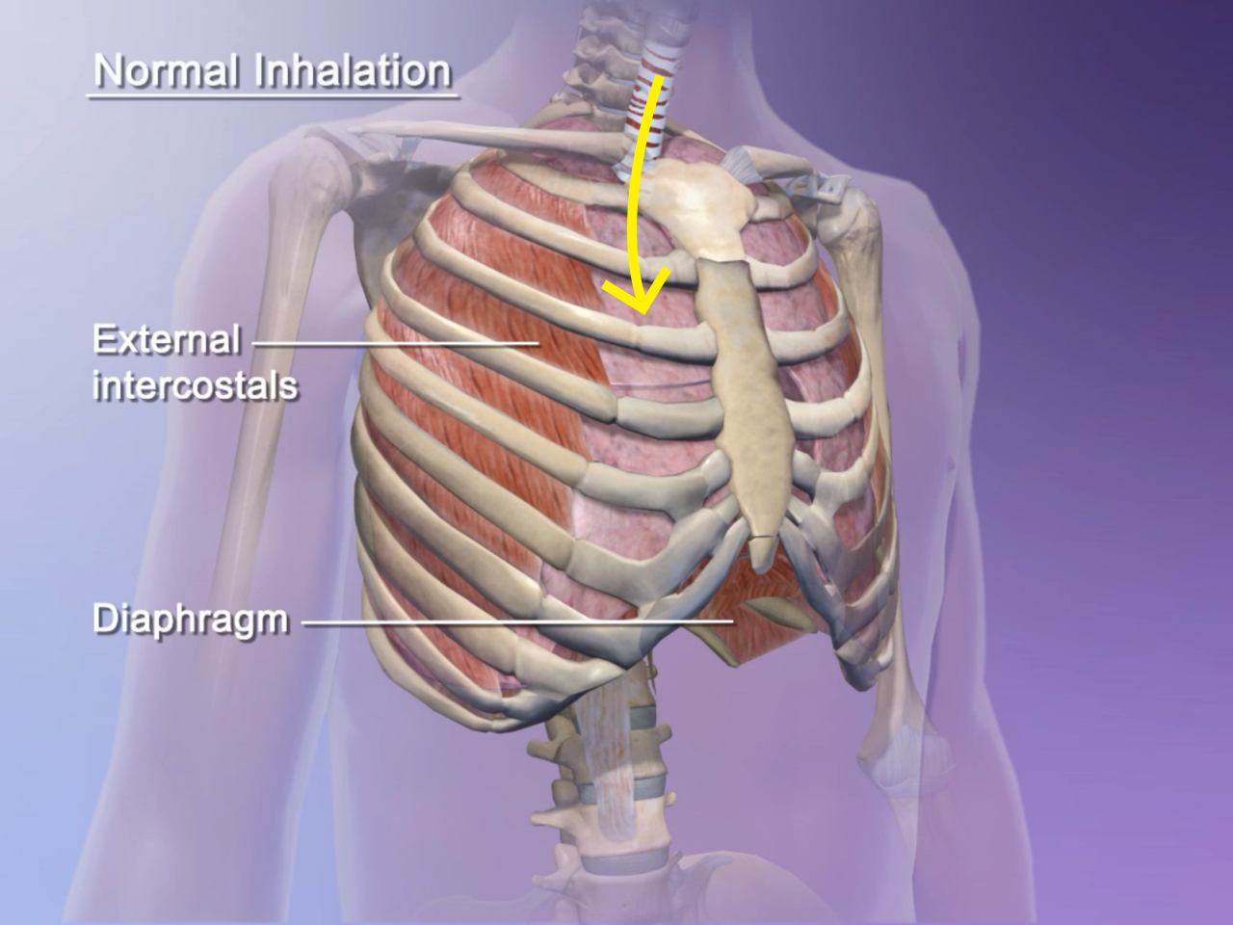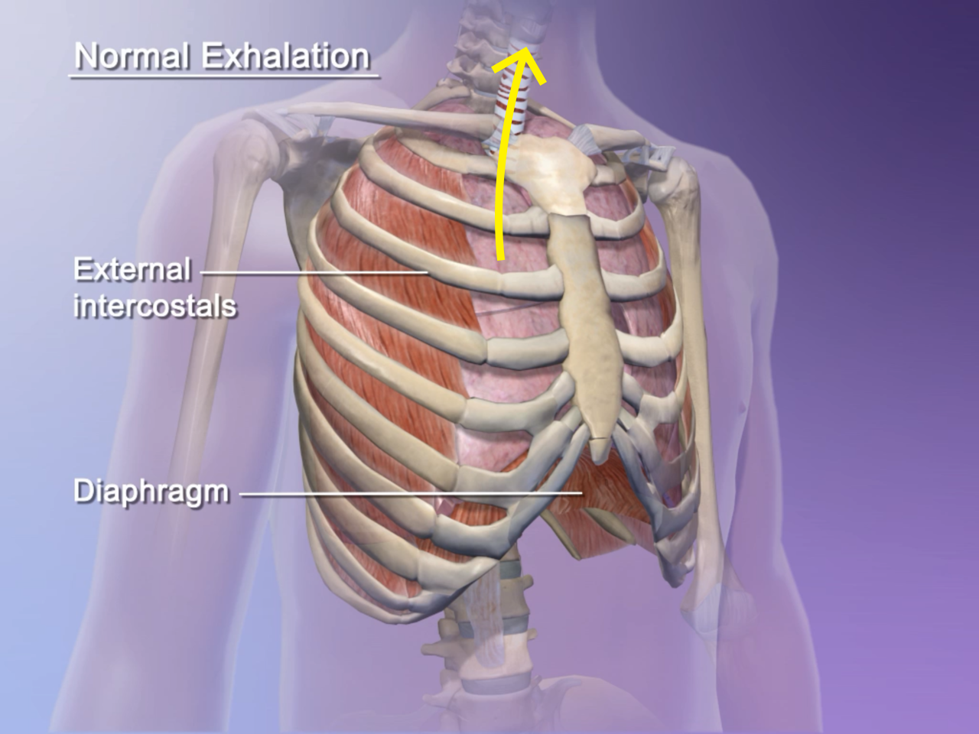

- The following images show the changes in volume and air pressure that occur in the lungs during normal inhalation and exhalation.

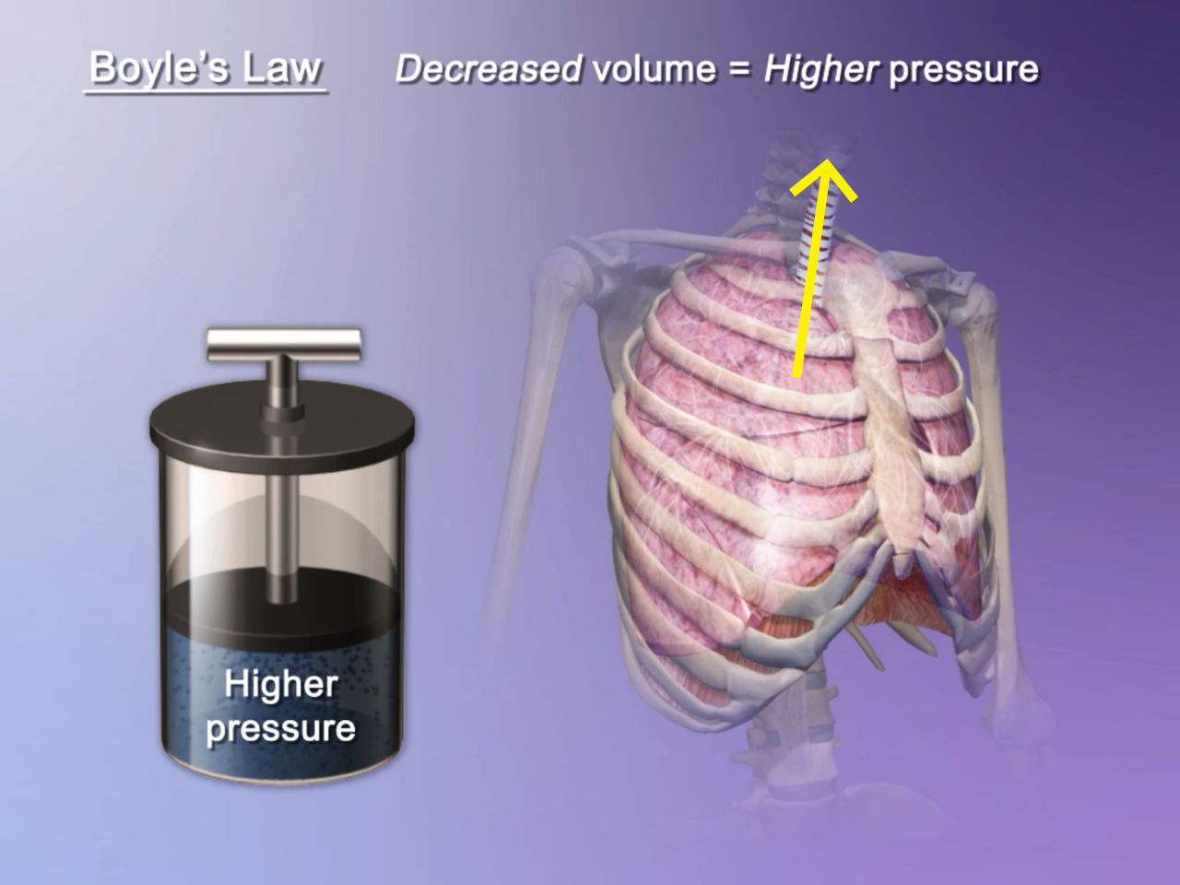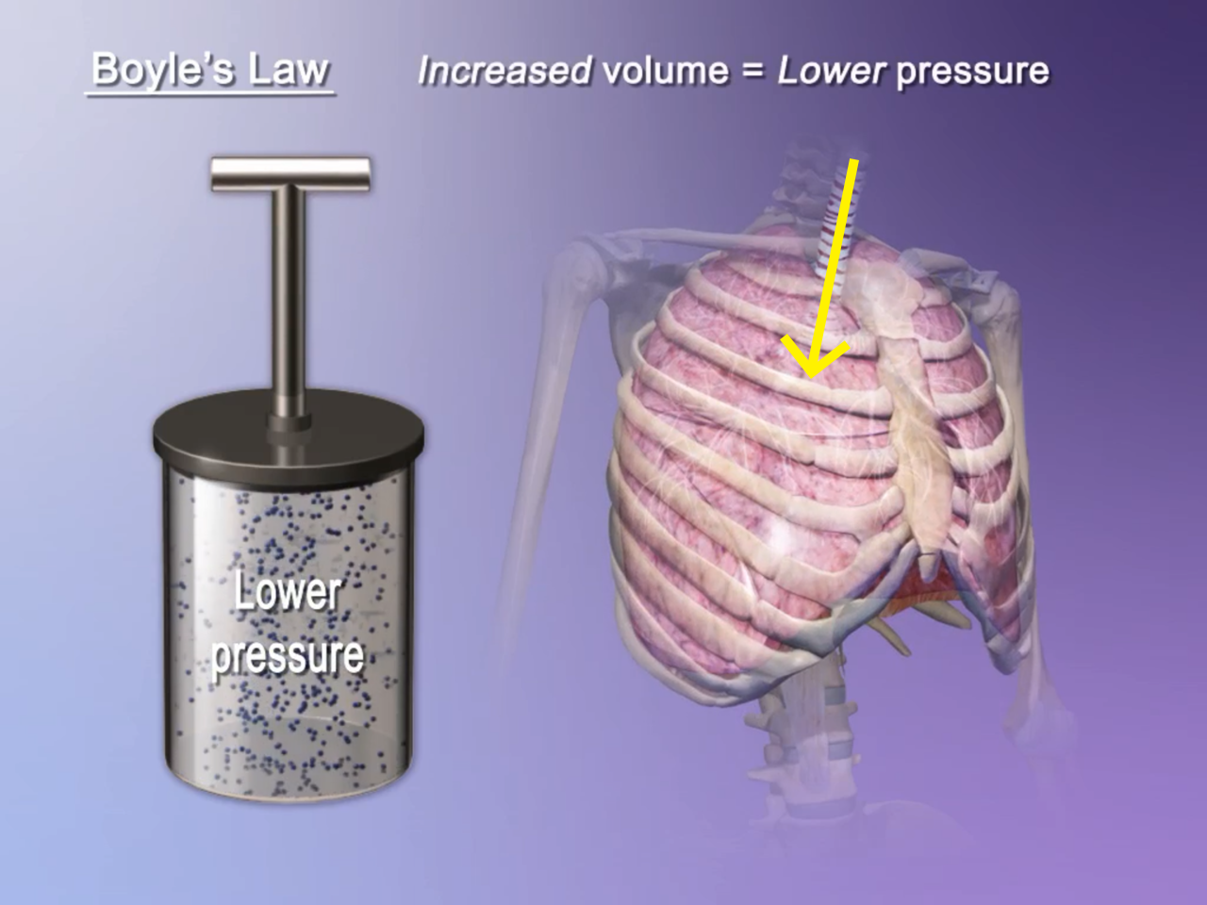

- Refer to the images in parts a and b and the Learn Site references provided in number 2 to help you complete the following table detailing the changes that occur in the lungs during inhalation and exhalation.

 | Inhalation | Exhalation
Muscle Actions:
Are the diaphragm and intercostals contracting or relaxing?
Lung Volume:
Is the volume of the lungs increasing or decreasing?
Air Pressure:
According to Boyle’s Law, does this change cause the air pressure to increase or decrease?
Air Flow:
Does this level of air pressure cause air to enter or leave the lungs?

Name: Date:
Lab 2: The Upper Respiratory System

Activity 1: Label the key structures of the upper respiratory system

- Read the Upper Respiratory System article on the Visible Body Learn Site.

- Match the numbered labels in the image below to the list included here:
  - Explore the 3D model of the upper respiratory structures in module 35.1 of the A&P app to find the structures you need to label.
  - Fill in the blanks to label the structures from the list below.

Word List:
Laryngopharynx ___ Nasopharynx ___
Larynx (and laryngeal skeleton) ___ Oropharynx ___
Nasal cavity ___ Paranasal sinuses ___

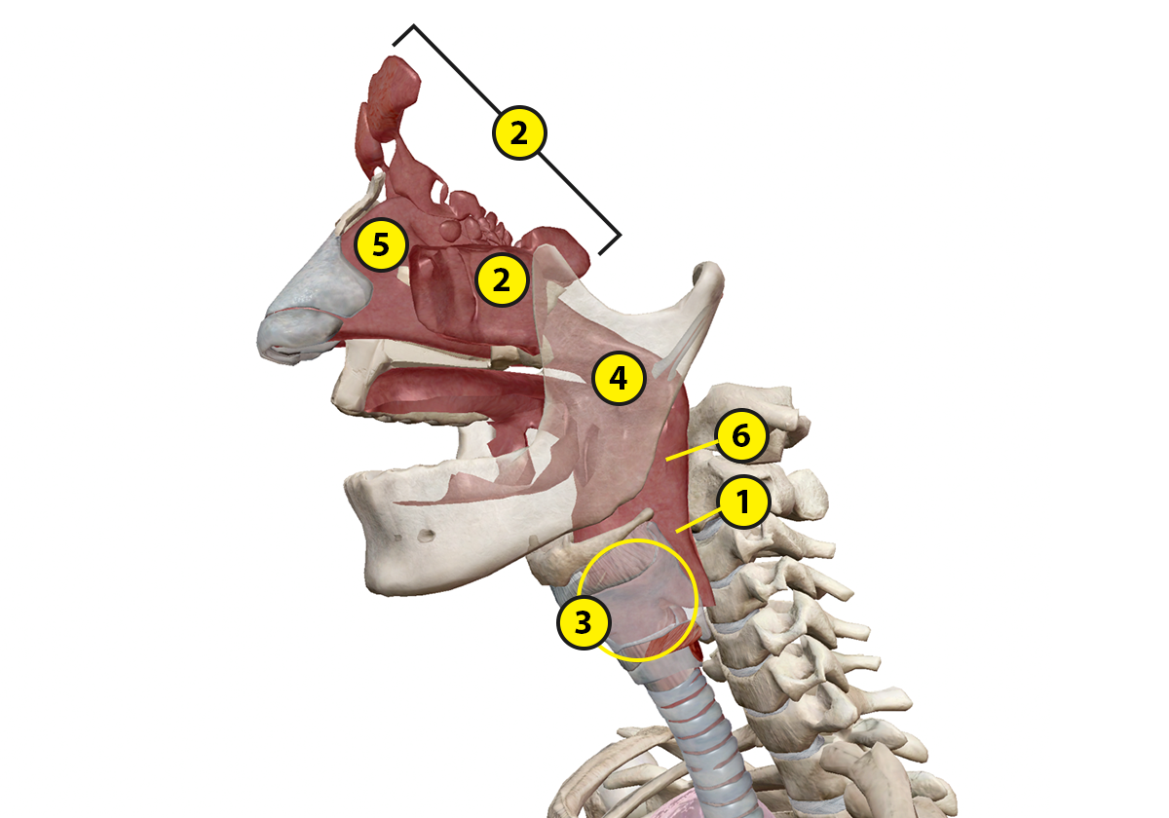

Name: Date:
Lab 2: The Upper Respiratory System

Activity 2: Explore the functions of the upper respiratory structures

Using your labeled upper respiratory tract image from Activity 1 and the A&P app modules on the upper respiratory system, match each of the following upper respiratory structures with its description.

Structures:
- Laryngopharynx
- Larynx
- Nasal cavity
- Nasopharynx
- Oropharynx
- Paranasal sinuses

Descriptions:
___ The most posterior part of the pharynx, this structure is shared by the
respiratory and digestive systems. The upper respiratory and upper
digestive tract diverge after this structure.
___ This structure is composed of the chambers of the internal nose, which
function as part of the upper respiratory system.
___ This structure keeps air passages open during breathing and digestion,
and it is the key organ for producing sound
___ These structures are lined with mucosae that help to warm and humidify
inhaled air.
___ The middle portion of the pharynx, this structure is shared by the
respiratory and digestive systems. It functions as an airway in the upper
respiratory system.
___ This structure is the portion of the pharynx that begins at the rear of the
nasal cavity, and it functions as an airway in the upper respiratory system.

Name: Date:
Lab 3: The Lower Respiratory System

Activity 1: Label the structures of the lower respiratory system

- Read the Lower Respiratory System article on the Visible Body Learn Site.

- Match the numbered labels in the image below to the list included here:
  - Explore the 3D models of the lower respiratory structures in modules 36.1 and 36.6 of the A&P app to find the structures you need to label.
  - Fill in the blanks to label the structures from the list below.

Word List:
Diaphragm ___ Right lung ___
External intercostal muscles ___ Trachea ___
Primary bronchi ___ Secondary bronchi ___
Left lung ___

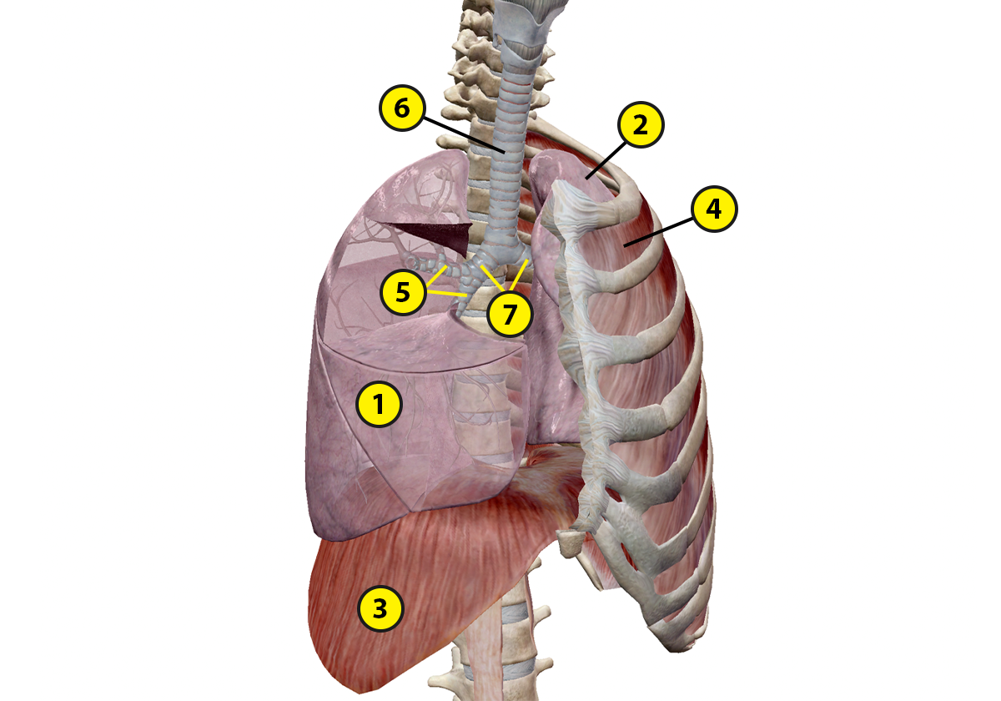

Name: Date:
Lab 3: The Lower Respiratory System

Activity 2: Label the structures of the alveoli

- Work through modules 36.11–36.14 in the A&P app and review the Lower Respiratory System article on the Visible Body Learn Site.

- Fill in the blanks to label the structures from the list below.

Word List:
Alveolus ___ Pulmonary capillary beds ___
Alveolar cavities ___ Pulmonary vein ___
Bronchiolar smooth muscle ___ Respiratory bronchiole ___
Pulmonary artery ___ Terminal bronchiole ___

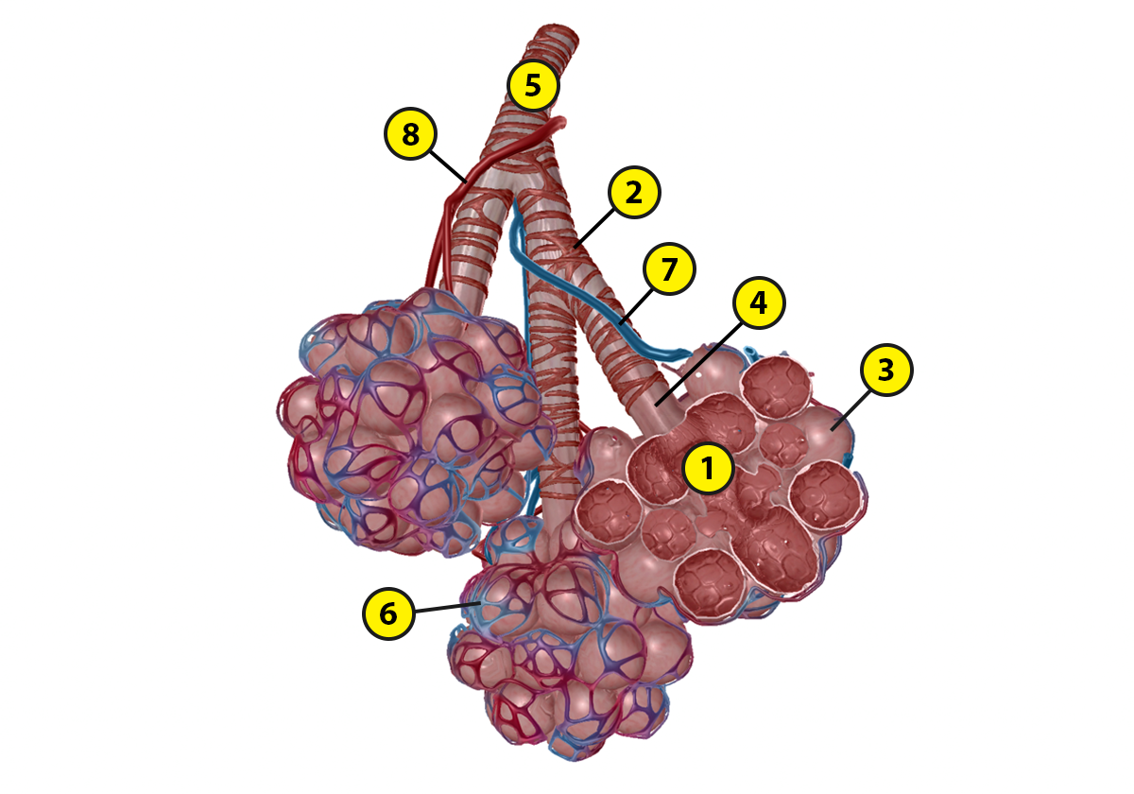

Name: Date:
Lab 3: The Lower Respiratory System

Activity 3: Explore the functions of the lower respiratory structures

Using your labeled lung and alveoli images from Activity 1, the modules from chapter 36 of the A&P app, and the Lower Respiratory System article on the Visible Body Learn Site, complete the following sentences on the lower respiratory structures.

- The _________ are the principal organs of the respiratory system. The right one has _____ lobes and the left one has _____ lobes.

- Circle the correct answers in the following sentences.
The diaphragm forms the floor of the thoracic cavity. During inhalation, it contracts/relaxes and moves inferiorly. During normal exhalation, it contracts/relaxes.

- The ___________ conveys air between the structures of the upper and lower respiratory system. It is covered by _____-shaped cartilaginous rings that prevent it from over-expanding or collapsing.

- The ___________ bronchi link the trachea with the right and left lungs. They are wrapped in rings of hyaline _____________ and their interiors are lined with a mucous membrane. They branch into increasingly smaller structures: first _____________ bronchi, then tertiary bronchi, and finally _______________.

- The ___________ are the main sites of gas exchange, where oxygen is brought into the bloodstream and carbon dioxide is ___________ from the bloodstream.

- During ______________, the alveoli fill with air from the bronchioles. Oxygen diffuses through the alveoli into _______________________. __________________ from deoxygenated blood diffuses into the alveoli and is expelled through ______________.

Name: Date:
Lab 4: Obstructed Airways

Activity 1: Measure perceived dyspnea

Dyspnea means “shortness of breath.” In this lab, you will record your experience of having an obstructed airway during rest and activity, using the Rating of Perceived Dyspnea scale.

The Rating of Perceived Dyspnea scale is a measurement of an individual's breathlessness and fatigue during exercise. The goal of this lab is to understand how altered respiratory system anatomy will affect a person’s physical capabilities.

Table 1: Rating of Perceived Dyspnea Scale
 | Shortness of Breath
0 | Nothing at all
0.5 | Very very slight
1 | Very slight
2 | Slight
3 | Moderate
4 | Somewhat severe
5 | Severe
6
7 | Very severe
8
9 | Very very severe
10 | Maximal

For more information about the Rating of Perceived Dyspnea scale, see the following resources:

- Assessing Shortness of Breath: https://pulmonaryrehab.com.au/patient-assessment/assessing-shortness-of-breath/
- Dyspnea Scale and Exercise: https://www.drugs.com/cg/dyspnea-scale-and-exercise.html
- Modified Medical Research Council Dyspnea Scale: https://www.mdcalc.com/mmrc-modified-medical-research-council-dyspnea-scale
- Rating of Perceived Exertion - Borg Scale: https://www.heartonline.org.au/media/DRL/Rating_of_perceived_exertion_-_Borg_scale.pdf

Directions:

Note: If you have a breathing issue such as asthma or a respiratory illness, you should not participate. Instead, work with a partner and discuss their ratings for each activity.

Materials: You will need a straw to complete this activity, and you may use a nose clip

- Block your nose with either a nose clip or your hand. You will keep the nose clip or your hand in place for the duration of the activity. In this activity, you will be breathing solely through your mouth.
- Sit for one minute and breathe normally through your mouth. Rate the difficulty of this activity in table 2. For example, if you are able to breathe with no trouble, you would rate this a zero.
- Run in place for one minute. Rate the difficulty of this activity in table 2.
- Rest for 1–2 minutes.
- While sitting, place the straw in your mouth and breathe through the straw for one minute. Rate the difficulty of this activity in table 2.
- Block your nose with either a nose clip or your hand. Place the straw in your mouth and run in place for one minute, while breathing through the straw. Rate the difficulty of this activity in table 2.

Table 2: Applying Rating of Perceived Dyspnea Scale
Activity | Blocked nose | Blocked nose and straw in mouth
Sit for 1 minute
Run in place for 1 minute

Name: Date:
Lab 4: Obstructed Airways

Activity 2: Explore your perceived dyspnea ratings

Using the measurements and observations you made in Activity 1, answer the following questions about your perceived dyspnea ratings.

- How did your dyspnea ratings differ between activities?

- Why was breathing through a straw during exercise more difficult than breathing normally during the same exercise?

- Could you tell that your accessory muscles were being used more while breathing through the straw? Why did this occur?

- What daily activities would be more difficult with an obstructed airway?

- Take a look at the COPD and asthma sections of the Respiratory Pathologies article on the Visible Body Learn Site (https://www.visiblebody.com/learn/respiratory/diseases-and-disorders). What anatomical changes are seen in both of these obstructive airway conditions?

- How does your experience during this exercise relate to that of individuals with asthma or COPD?

- What symptoms would an individual with severe dyspnea experience?

