Name: Date:

Biology Lab Activities: Human Body (Nervous System)
Last updated: 11/1/22

Background Questions

Read through the Nervous System Overview article on the Visible Body Learn Site and explore the 3D model of the central nervous system.

Based on what you’ve learned in class, in your textbook, and from the Learn Site article, answer the following questions about the nervous system.

- The nervous system receives information from the sensory organs via __________, transmits the information through the _______________, and processes it in the _________.

- The brain and spinal cord make up the central nervous system (CNS). The spinal cord transmits signals to and from the _________ and commands ____________, immediate responses that don’t require the brain’s input. The brain connects ______________ to complex thought, memory, and emotion.

- The ______________ nervous system (PNS) is made up of the cranial nerves, spinal nerves, and sensory organs.

- All nervous tissue includes cells called ___________, which conduct ______________________ to pass information through the body.

- Messages pass from one neuron to another with the help of chemicals called _____________________.

Name: Date:

Lab 1: Neurons

Activity 1: Label the parts of a neuron

- Read the Neurons article on the Visible Body Learn Site.
- Match the numbered labels in the image below to the list included here:
  - Explore the 3D model of the neuron in your browser or in AR to find the structures you need to label.
  - Fill in the blanks to label the structures from the list below.

Word List:
Axon
Axon terminal
Cell body
Dendrite
___
___
___
___

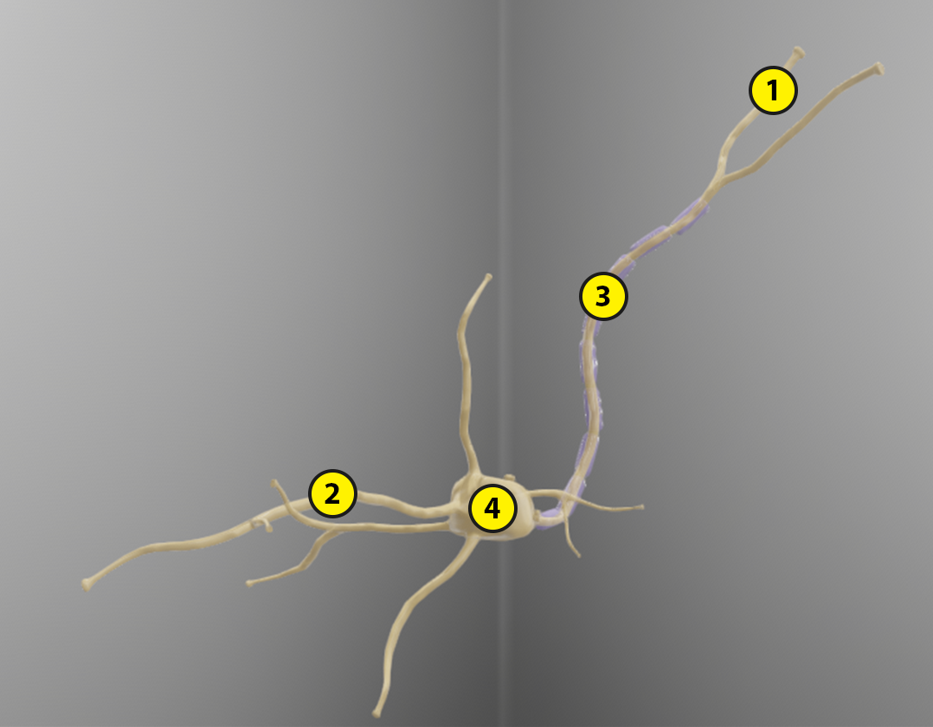
Name: Date:

Lab 1: Neurons

Activity 2: Explore how the nervous system transmits signals

Use your labeled neuron image from Activity 1 and the Nervous System Glossary on the Visible Body Learn Site to match each of the following structures with its function.

Structures:
- Neurons
- Neuroglia
- Axon
- Dendrites
- Synapse
- Neurotransmitters

Functions:
___ Nervous system cells that conduct electrical signals via axons
___ The neuron’s “tail”—surrounded by a myelin sheath—which carries action
potentials away from the cell body
___ Nervous system cells that support neurons and other structures that supply and
surround nervous tissue
___ Structures that branch off from a neuron’s cell body and receive signals from
other neurons
___ Chemicals that are released to other neurons or cells, stimulating or inhibiting
signals and responses
___ The space between the axon terminal of a neuron and the dendrites of
surrounding neurons

Name: Date:

Lab 2: The Brain

Activity 1: Label the major regions and lobes of the brain

- Read the Human Brain article on the Visible Body Learn Site.
- The brain consists of four major regions that help it carry out its functions, which include directing the body’s internal functions; forming perceptions, thoughts, and memories; and coordinating body movements and speech. Label the four major regions of the human brain by matching the numbered labels in the image below to the list included here:
  - Explore the 3D model of the brain in your browser or in AR to find the structures you need to label.
  - Fill in the blanks to label the structures from the list below.

Word List:
Cerebrum
Diencephalon
Cerebellum
Brainstem
___
___
___
___

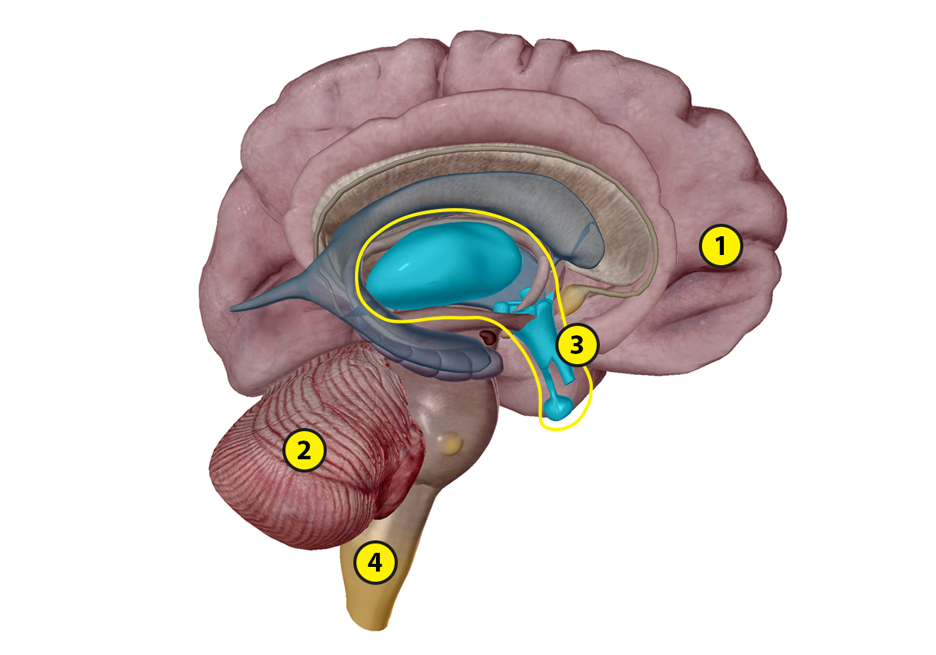

- The cerebrum is the largest brain structure. Its prominent outer portion, the cerebral cortex, has a left and right hemisphere. Each of these hemispheres has four lobes. Label the lobes by matching the numbered labels in the image below to the list included here:
  - Explore the 3D model of the brain in your browser or in AR to find the structures you need to label.
  - Fill in the blanks to label the structures from the list below.

Word List:
Frontal lobe
Temporal lobe
Parietal lobe
Occipital lobe
___
___
___
___

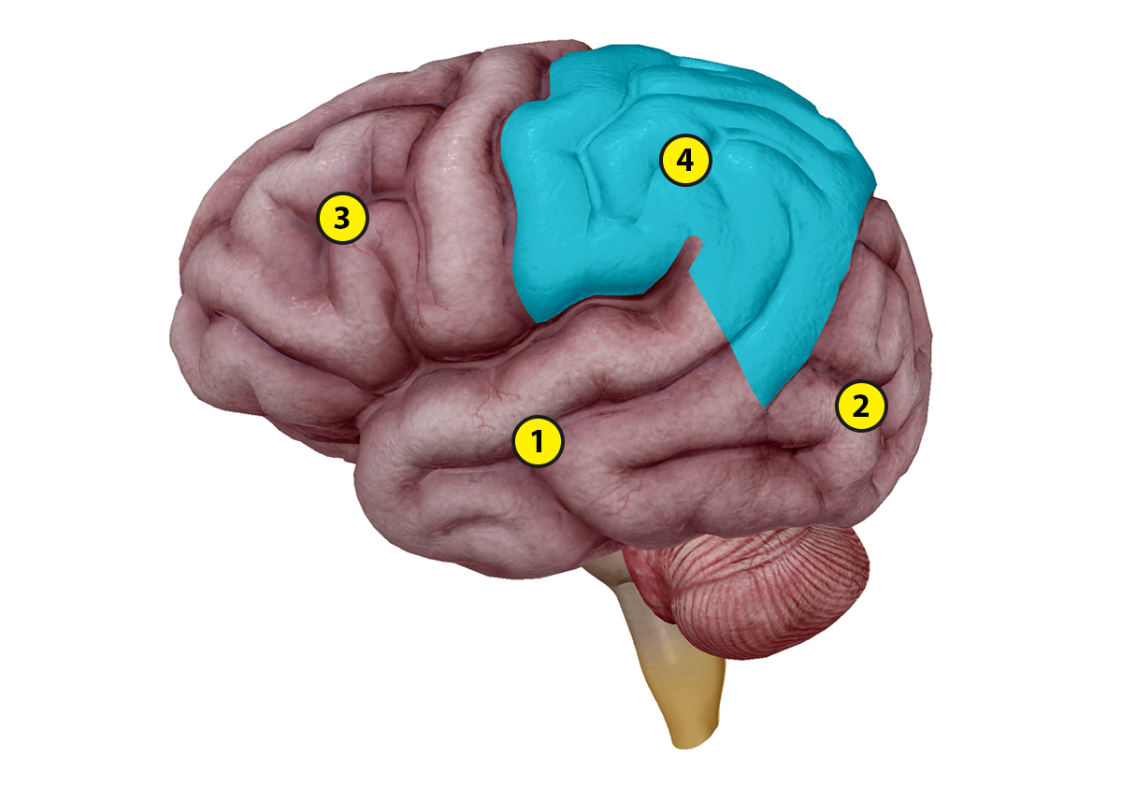

Name: Date:

Lab 2: The Brain

Activity 2: Explore the key functions of the brain regions

Use your labeled brain regions and brain lobes images from Activity 1 and the Nervous System Glossary on the Visible Body Learn Site to complete the following exercises about the regions of the brain and their functions.

- The cerebrum gives us conscious control of our actions. Its prominent outer portion is called the ____________________. Its tissue consists mainly of __________ cell bodies. The cerebral cortex contains folds called ________ and fissures called _________.

- The cerebral cortex is divided into _______ hemispheres, which can each be divided into ________ lobes.

In the following table, fill in the missing details about the lobes of the cerebral cortex and their functions.

Lobe | Functions
___________ lobe | - Speech  - Planning  - Long-term memory
____________ lobe | - Receives input from the cochlear nerve  - Integrates auditory, olfactory, and complex pattern perception
Parietal lobe | - Integrates sensory information  - Gives the perception of _________  - Plays a role in spatial perception
Occipital lobe | - Receives input from the _____________________  - Processes visual perceptions

- What is the primary function of the cerebellum?

- The brainstem connects the spinal cord to the brain. What three structures make up the brainstem?

- Together, the structures of the brainstem relay ___________ and _________ signals and direct _______________ functions such as breathing, digestion, and circulation.

- Which part of the brain serves as a “sorting station” that receives sensory data and relays it to different parts of the cerebral cortex?

- In addition to the nervous system, the hypothalamus plays a role in the ________________ system. Describe that role in 1–2 sentences.

- The hypothalamus also manages the _____________ nervous system, which regulates sleep cycles and food consumption, as well as body chemistry and temperature.

Name: Date:

Lab 3: Special Senses Overview

Activity 1: Review the special senses and their receptor cells

Use the Five Senses article and Nervous System Glossary on the Visible Body Learn Site to complete the following table. For each of the special senses, enter the primary sensory organ, type(s) of receptor cells, and what the receptor cells respond to.

 | Primary sensory organ | Receptor cells | What do the receptor cells respond to?

Hearing

Smell

Touch

Taste

Vision

Name: Date:

Lab 4: Special Senses—Vision

Activity 1: Label the parts of the eye

- Read the Introduction and Section 1 of the Five Senses article on the Visible Body Learn Site.
- Match the numbered labels in the image below to the list included here:
  - Follow the link in the Eye entry of the Nervous System Glossary to explore a 3D model of the eye and find the structures you need to label.
  - Fill in the blanks to label the structures from the list below.

Word List:
Cornea
Choroid
Iris
Pupil
Optic Nerve
Retina
Sclera
___
___
___
___
___
___
___

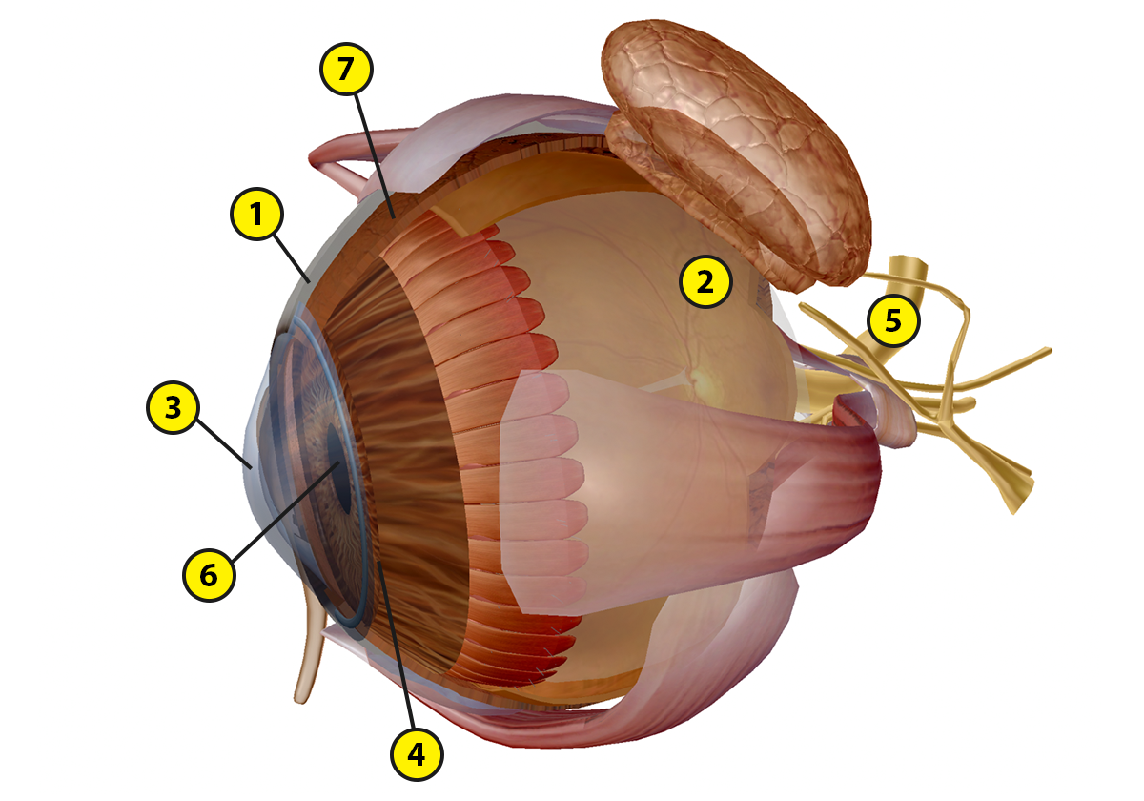

Name: Date:

Lab 4: Special Senses—Vision

Activity 2: Create a model eye

Use your labeled eye image from Activity 1 and the Nervous System Glossary on the Visible Body Learn Site to create a model eye and explore how the eye focuses light to create an image. This activity is adapted from Visible Body’s A&P Vision Lab Manual.

List of supplies:
- 3 small paper cups
- Wax paper
- Pin for poking holes in cups
- Black marker or black construction paper

Activity:
- Cut the bottom out of one of the paper cups and attach the wax paper to it to create a new bottom. Keep the wax paper as smooth as possible. The wax paper will simulate the retina.

- Take your second cup and use a pin to poke a small hole in the center of the bottom of the cup. This hole is the pupil.

- Place the wax paper cup inside the cup with the small hole in the bottom.

- Go to a bright window and adjust the spacing between the two cups. You should be able to see an image on the wax paper, but it will not be quite clear.

- Take your third paper cup and use a black marker to color the inside, or line it with black construction paper. This dark lining simulates the choroid. Poke a small hole in the bottom of this cup (going through the black construction paper as well as the cup, if you’re using construction paper). Look out the same window as before with this cup on the outside of your wax paper cup.

Discussion Questions

- How does the black cup affect image clarity?

- What does the choroid do to help your eye see more clearly?

- Now, for one last experiment, make the hole in the bottom cup larger. This simulates the pupil dilating. What happens to the clarity and brightness of your image?

- What structure controls the size of the pupil?

- What is the purpose of the pupil dilating in low light conditions and constricting in high light conditions?

Name: Date:

Lab 5: Special Senses—Hearing

Activity 1: Label the parts of the ear

- Read Section 2 of the Five Senses article on the Visible Body Learn Site.
- Match the numbered labels in the image below to the list included here:
  - Follow the link in the Ear entry in the Nervous System Glossary to explore a 3D model of the ear and find the structures you need to label.
  - Fill in the blanks to label the structures from the list below.

Word List:
Cochlea
Cochlear nerve
Ear canal
Incus
Malleus
Semicircular canals
Stapes
Tympanic membrane
Vestibule
Vestibulocochlear nerve
___
___
___
___
___
___
___
___
___
___

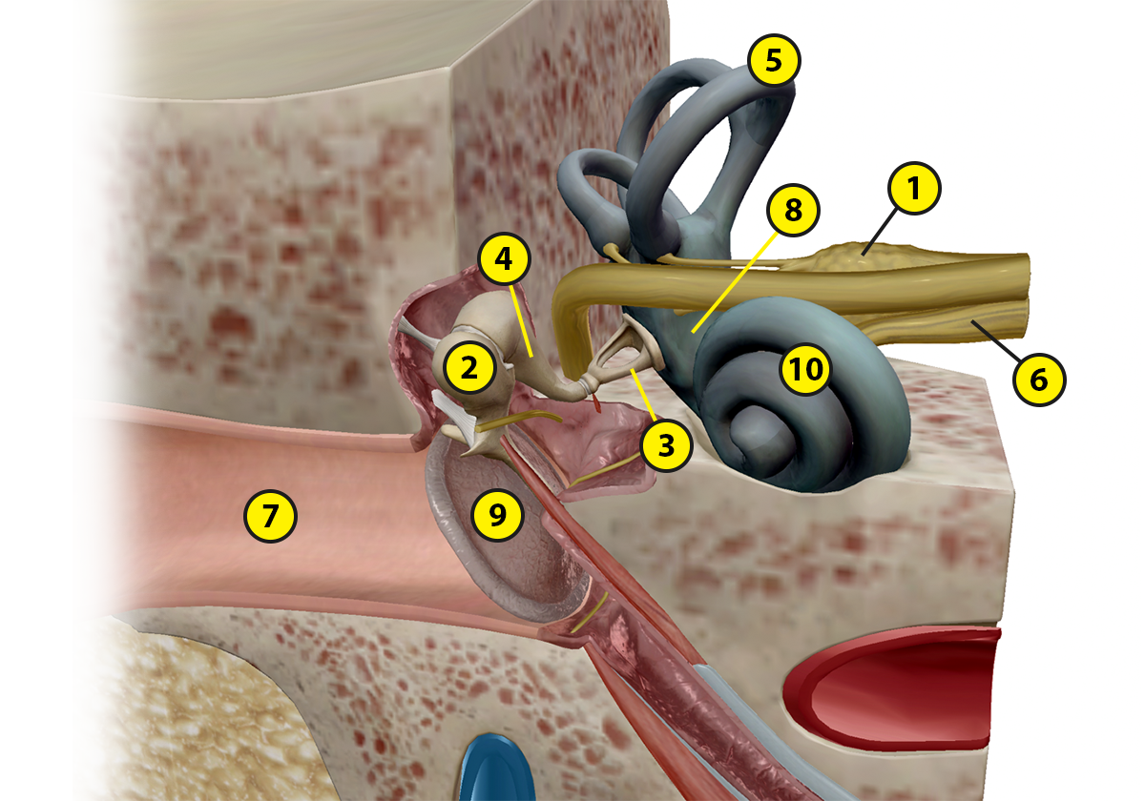
Name: Date:

Lab 5: Special Senses—Hearing

Activity 2: Explore how the ears turn sound waves into electrical signals

Use your labeled ear image from Activity 1 and the Nervous System Glossary on the Visible Body Learn Site to complete the following exercises about hearing.

- Complete the following sentences about the structures involved in hearing.

  - The hair cells activate nervous receptors and send signals through the ____________ nerve to the brain.

  - The sound waves create vibrations in the _____________________, or eardrum.

  - The auditory ossicles—the ___________, incus, and stapes—carry the vibrations from the middle ear to the inner ear.

  - The outer ear funnels sound waves down the _____________.

  - The inner ear consists of canals filled with fluid. Specialized ________ cells in the spiral-shaped ___________ detect pressure waves in this fluid.

- Put the statements from (1) in the correct order. You can write out or copy/paste the statements or just use their letters from (1).

Name: Date:

Lab 6: Special Senses—Touch, Smell, and Taste

Activity 1: Label the touch receptors in the skin

- Read Section 3 of the Five Senses article on the Visible Body Learn Site.
- Match the numbered labels in the image below to the list included here:
  - Go to the Visible Body Blog to explore the 3D model of the skin in your browser or in AR and find the structures you need to label.
  - Fill in the blanks to label the structures from the list.

Word List:
Epidermis
Dermis
Free nerve ending
Hypodermis
Meissner’s corpuscle
Merkel cell
Pacinian corpuscle
___
___
___
___
___
___
___

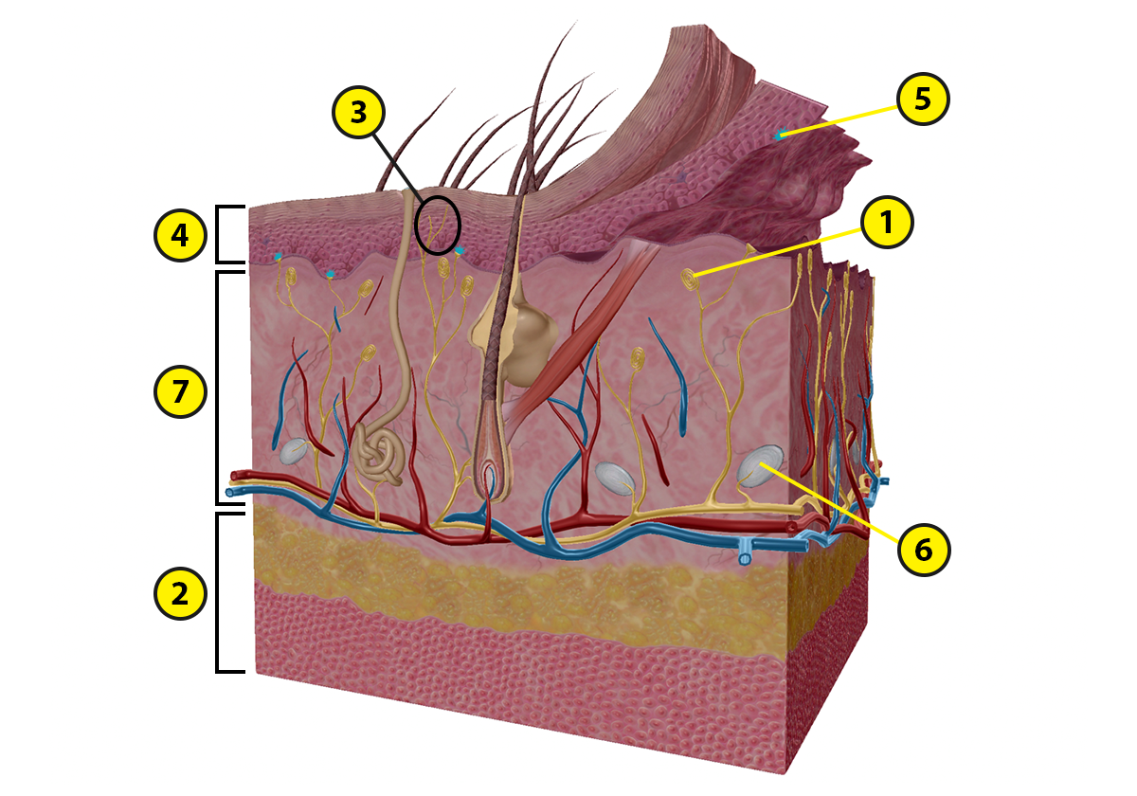

Name: Date:

Lab 6: Special Senses—Touch, Smell, and Taste

Activity 2: Explore the functions of the different receptors in the skin

Use your labeled touch receptors image from Activity 1 and the Nervous System Glossary on the Visible Body Learn Site to match each of the following structures with its function.

Structures:
- Merkel cells
- Meissner’s corpuscles
- Pacinian corpuscles
- Free nerve endings

Functions:
___ Receptors—found in the upper dermis of hairless skin, including the fingertips, nipples,
and soles of the feet—that detect touch, pressure, and vibration
___ Receptors that register pressure and vibration
___ Specialized receptors that feel pain, itching, and tickling
___ Receptors—found in the lower epidermis of the lips, hands, and external genitalia—that
detect touch, pressure, and vibration

Name: Date:

Lab 6: Special Senses—Touch, Smell, and Taste

Activity 3: Label the structures involved in olfaction

- Read Section 4 of the Five Senses article on the Visible Body Learn Site.
- Match the numbered labels in the image below to the list included here:
  - Watch the animation on olfaction to find the structures you need to label.
  - Fill in the blanks to label the structures from the list below.

Word List:
Nasal cavity (L)
Olfactory bulb (L)
Olfactory nerve (L)
___
___
___

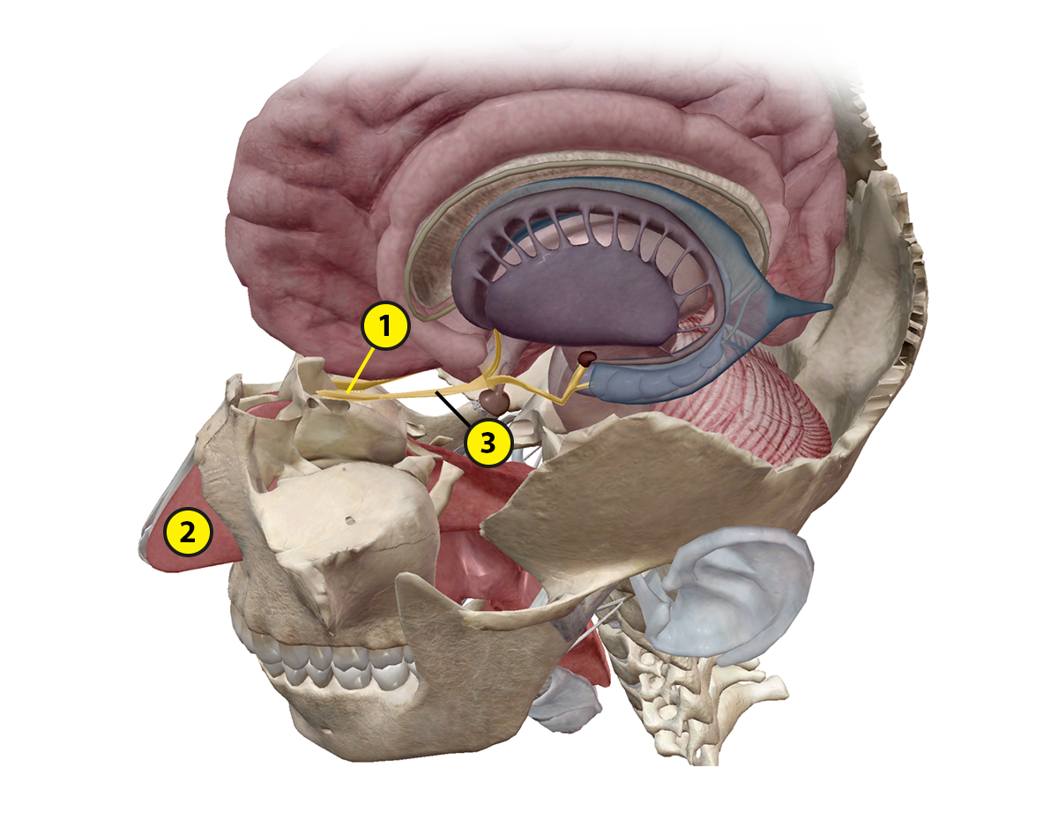

Name: Date:

Lab 6: Special Senses—Touch, Smell, and Taste

Activity 4: Label the tongue

- Read Section 5 of the Five Senses article on the Visible Body Learn Site.
- Match the numbered labels in the image below to the list included here:
  - Explore the 3D model of the tongue in your browser or in AR and look at the illustration of the tongue and taste buds to find the structures you need to label.
  - Fill in the blanks to label the structures from the list below.

Word List:
Circumvallate papillae
Fungiform papillae
Taste buds
___
___
___

