Name: Date:

Body Movement Lab
Last updated: 10/17/22

Activity 1: Flexion/Extension

Part 1: Flexion
- Launch Muscle Premium.
- Navigate to Actions, then find Elbow Flexion under Upper Limbs.
- Play the animation. Select the icon for a description of the movement.
- Note the change in angle of the elbow joint during elbow flexion. Then, in 1–2 sentences, describe how the angle changes with the movement.
- There are three muscles that act as agonists (prime movers) in this movement. Select each muscle in Elbow Flexion to learn its name. Then, identify the structures indicated by each letter on the image below, and fill in their names in the corresponding spaces beneath the image.
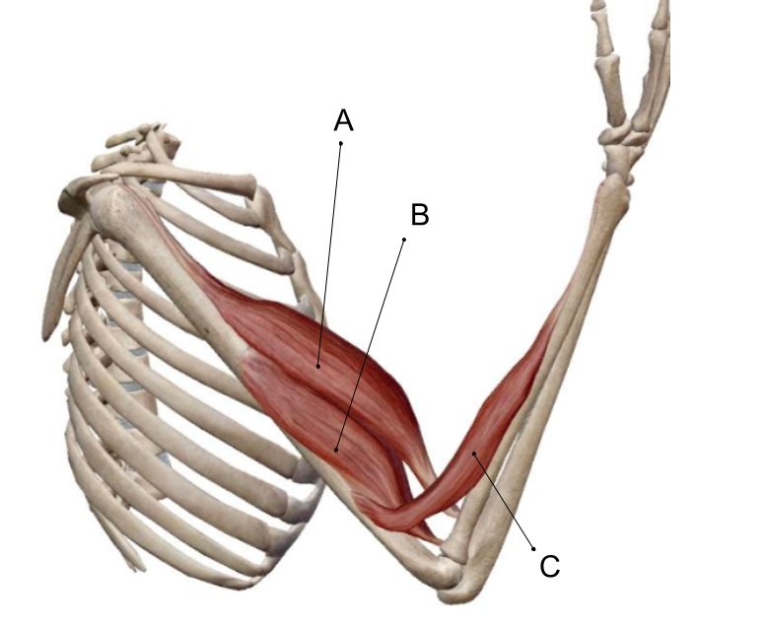

Part 2: Extension
- Navigate to Actions, then find Elbow Extension under Upper Limbs.
- Play the animation. Select the icon for a description of the movement.
- Note the change in angle of the elbow joint during elbow extension. In 1–2 sentences, describe how the angle changes with the movement.

- There is one muscle with three heads that acts as an agonist (prime mover) in this movement. Select the muscle in Elbow Extension to learn its name. Then, identify the structure indicated by the letter “A” on the image below, and fill in its name in the corresponding space beneath the image.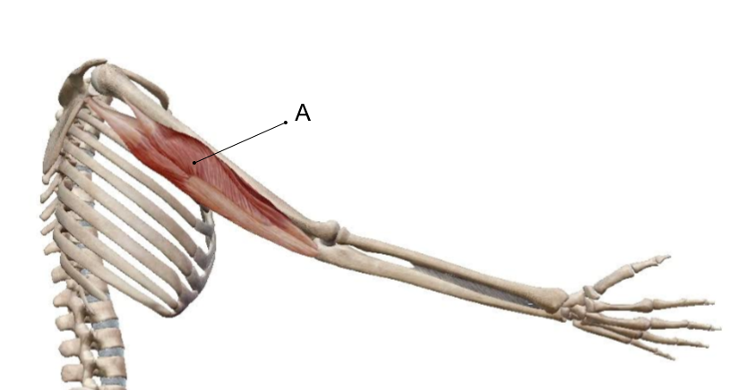

- In 1–2 sentences, explain how the movement of elbow extension is the opposite of the movement of elbow flexion.

- Observation: Take a moment to notice the location of the muscles responsible for each movement above. Note that they are located (originate) on the side of the bones toward which the motion occurs. Recognizing the direction of the motion will help you identify the muscles that cause the motion. Muscles pull an insertion point toward an origin.

- Using the information learned in this activity, match the following terms to the appropriate description:

___ Flexion
___ Extension
___ Triceps brachii
___ Biceps brachii

a. Agonist in elbow flexion
b. A movement decreasing the angle of a joint
c. Agonist in elbow extension
d. A movement increasing the angle of a joint

Name: Date:

Body Movement Lab

Activity 2: Abduction/Adduction
- Launch Muscle Premium.
- Navigate to Actions, then find Shoulder Abduction under Shoulder.
- Play the animation. Select the icon for a description of the movement and make note of the agonists (prime movers).

- Describe the movement in 1–2 sentences.

- Navigate to Actions, then find Shoulder Adduction under Shoulder.
- Play the animation. Select the icon for a description of the movement and make note of the agonists (prime movers).

- Describe the movement in 1–2 sentences.
- Which muscle on the image below is an agonist for shoulder abduction? A or B? What is the name of that muscle? Make the text of the muscle name blue to represent abduction.

- Which muscle on the image below is an agonist for shoulder adduction? A or B? What is the name of that muscle? Make the text of the muscle name red to represent adduction.

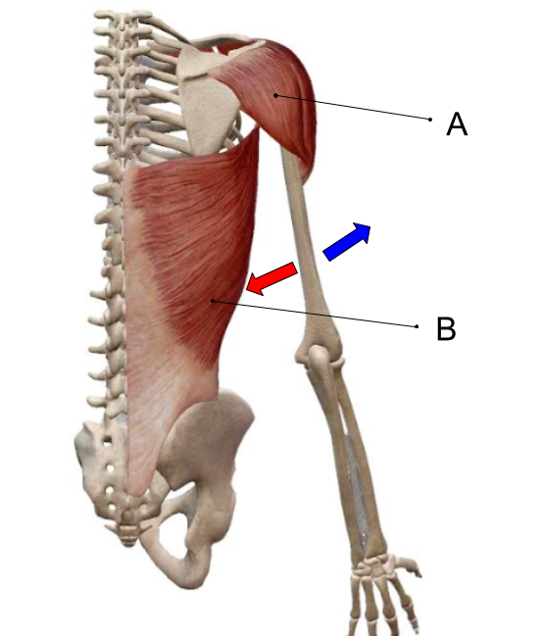

- In the image above, what movement does the blue arrow represent? What movement does the red arrow represent?
- Using the information learned in this activity, match the following terms to the appropriate description:

___ Adduction
___ Abduction
___ Deltoid
___ Latissimus dorsi
a. Agonist in shoulder abduction
b. Agonist in shoulder adduction
c. A movement of a limb away from the midline
d. A movement of a limb toward the midline

- Adduction and abduction are movements in relation to the midline. We have explored the shoulder joint in this activity. Name another joint that can also perform these movements and use the Muscle Premium app to find the following information.

Name of joint:
Agonist for adduction of this joint:
Agonist for abduction of this joint:

Name: Date:

Body Movement Lab

Activity 3: Forearm and Ankle Movements

Part 1: Forearm Movements
- Launch Muscle Premium.
- Navigate to Actions, then find Forearm Pronation under Upper Limbs.
- Play the animation. Select the icon for a description of the movement.

- Describe the movement in 1–2 sentences.
- Now, find Forearm Supination under Upper Limbs.
- Play the animation. Select the icon for a description of the movement.

- How is this movement different from forearm pronation?

Part 2: Ankle Movements
- Navigate to Actions, then find Foot Inversion under Lower Limbs.
- Rotate the model to observe the anterior side of the lower limb.
- Play the animation. Select the icon for a description of the movement.

- Describe the movement in 1–2 sentences.

- Next, navigate to the Pathologies section, then find Ankle Sprain under Lower Limbs.

- What is the primary ligament affected by this inversion injury?

- Now, navigate back to Actions, then find Foot Eversion under Lower Limbs.
- Rotate the model to observe the anterior side of the lower limb.
- Play the animation. Select the icon for a description of the movement.

- Describe the movement in 1–2 sentences.

- Explain how eversion is the opposite of inversion in 1–2 sentences.
- Eversion and inversion are represented on the image of the right ankle below. What movement is represented by A? What movement is represented by B?
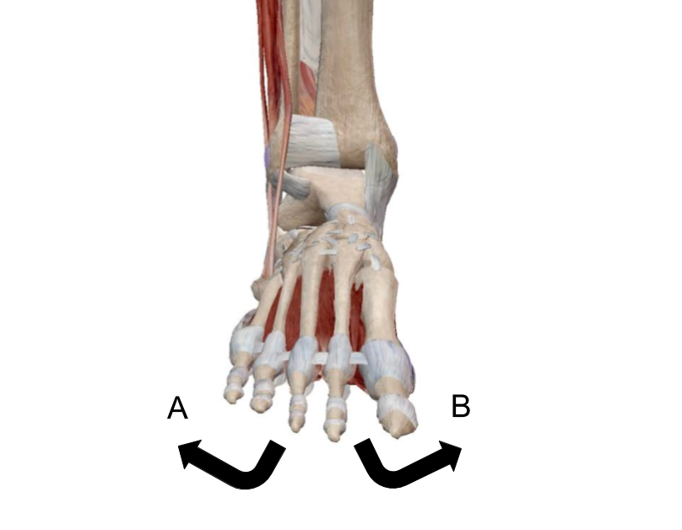

- Next, navigate to Actions, find Dorsiflexion under Lower Limbs and play the animation. Select the icon for a description of the movement. Then, navigate to Plantarflexion under Lower Limbs and do the same.

- Fill in the blanks using the information found in Dorsiflexion and Plantarflexion: Dorsiflexion involves muscles on the __________ side of the lower limb. Plantarflexion is the movement of pointing the toes toward the __________. The gastrocnemius is an agonist in __________.

- Dorsiflexion and plantarflexion are represented on the image of the right ankle below. What movement is represented by A? What movement is represented by B?
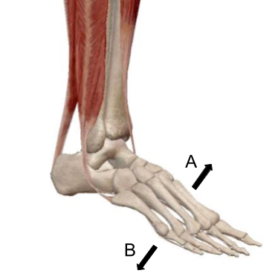

Name: Date:

Body Movement Lab

Activity 4: Jaw Movements
- Launch Muscle Premium.
- Navigate to Actions, then find Mandible Elevation under Head and Neck.
- Play the animation. Select the icon for a description of the movement, and select the muscles involved to learn their names.
- Repeat the steps above for Mandible Depression, Mandible Protraction, and Mandible Retraction.

- Fill in the table below with descriptions for each movement.
Movement | Description of Action
Mandible Elevation
Mandible Depression
Mandible Protraction
Mandible Retraction

- Identify the structures indicated by each letter in the image below, and fill in their names in the corresponding spaces beneath the image.
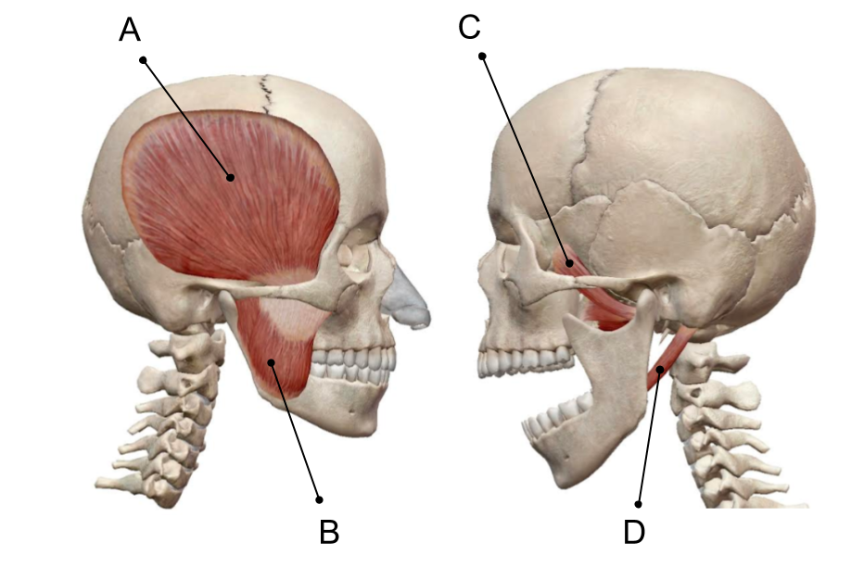

Name: Date:

Body Movement Lab

Activity 5: Rotation

Part 1: Head Movements
- Launch Muscle Premium.
- Navigate to Actions, then find Head Rotation (Ipsilateral) under Head and Neck.
- Play the animation and answer the following question.
- Rotation is a movement made about a longitudinal axis in a transverse plane. What is the axis in the head rotation?

Part 2: Shoulder Movements
- Navigate to Actions, then find Shoulder Medial Rotation under Shoulder. Play the animation.
- Next, navigate to Shoulder Lateral Rotation. Play the animation.

- The longitudinal axis of both the above actions is the long axis of the humerus. Describe the difference between medial rotation and lateral rotation.

Part 3: Making Connections
The hip joint can also perform medial and lateral rotations. (Hint: Navigate to Actions, then find Hip Medial Rotation and Hip Lateral Rotation under Pelvis and play the animations.) Using your knowledge of shoulder rotation, complete the following questions:

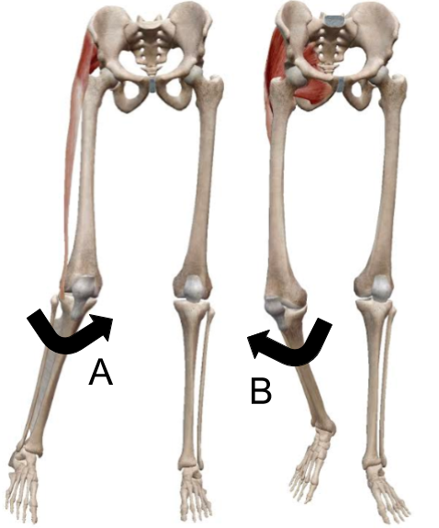

- Which type of rotation is shown in image A?

- Which type of rotation is shown in image B?

- What bone is the longitudinal axis for both of these rotations?

